
Safeguarding in the Parish of Freshford with Limpley Stoke and Hinton Charterhouse
Do you feel safe?
You should feel safe wherever you are. If you feel unsafe or think someone else is unsafe and needs help and advice, please contact our safeguarding team.

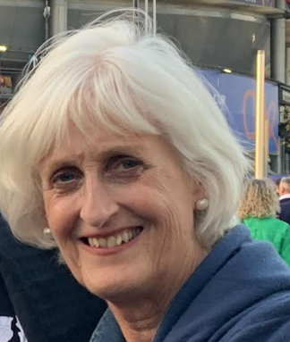
Parish Safeguarding Officer
Lesley MacKenzie 07808 923946
lesleyjmackenzie@gmail.com

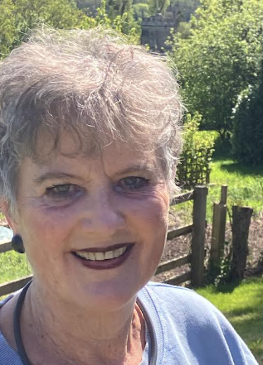
Pastoral Coordinator
Rachel Moore
rachelfreshford@gmail.com
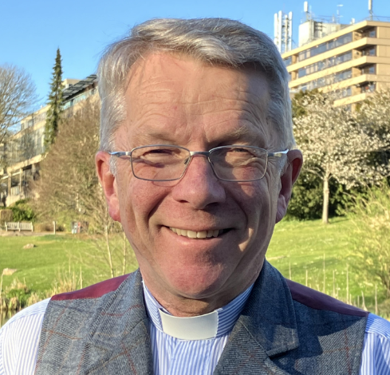
Rector
Rev Nigel Rawlinson 07304 498491
rector@flshc.co.uk

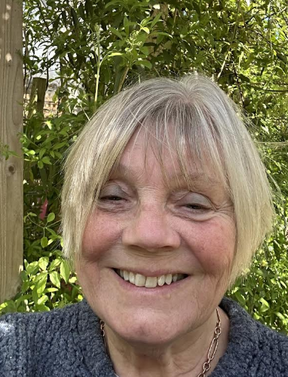
School Coordinator
Penny Murray
pennylanemurray@aol.com

